TUNNEL SUSPENSION SYSTEM
LH + HPS | Threaded eye • Grade 8.8 rod • Drop-in anchor
Complete suspension component packages in M8 and M16, with a galvanized DIN 582 eye, galvanized DIN 976 threaded rod and a choice of drop-in anchor. Intended application: overhead suspension in tunnel environments, subject to project-specific anchor design and verification.
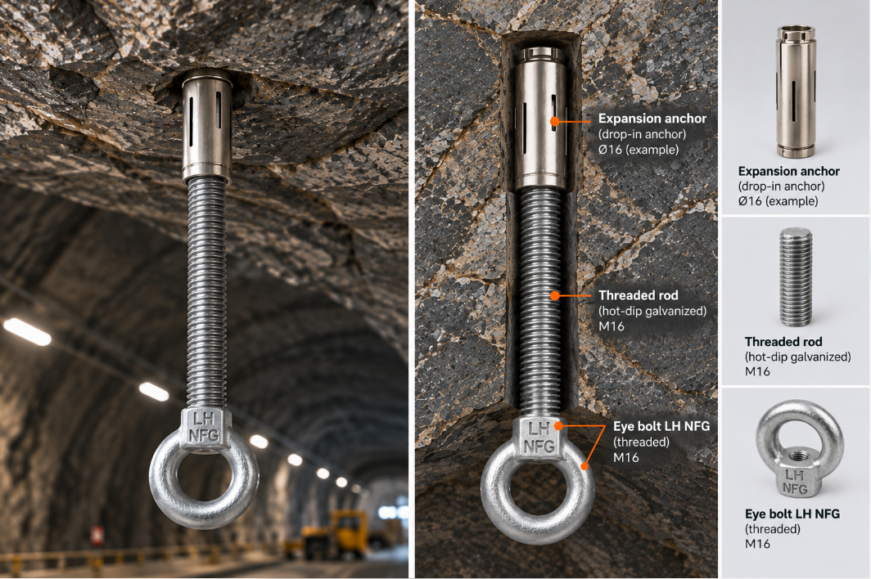

Package overview
Package | Size | NFG article | Rod length | Anchor options
LH + HPS 1 | M8 | 990012858 | 150 mm | HE-A4 / HE-NS
LH + HPS 2 | M16 | 990012859 | 150 mm | HE-A4 / HE-NS

Illustration is schematic; installation and load capacity must be assessed for the actual rock substrate. The supplied reference document includes concrete-anchor dimensional diagrams.

Components & materials
Component | M8 article | M16 article | Specification / finish
LH eye | 14480800000205 | 14481600000205 | DIN 582 • C15 • HDG, EN 10684
HPS threaded rod | 13370801500205 | 13371601500205 | DIN 976 • Class 8.8 • HDG, EN 10684
HE-A4 drop-in anchor | HEA4M08 | HEA4M16 | Stainless steel A4
HE-NS drop-in anchor | HENSM08 | HENSM16 | Steel • Atlantis coating (described as similar to HDG)

LH eye — dimensions and stated maximum loads
Parameter | M8 | M16
h | 36 mm | 62 mm
b | 13 mm | 27 mm
d2 | 36 mm | 63 mm
d3 | 20 mm | 35 mm
d4 | 20 mm | 35 mm
k | 8 mm | 14 mm
Max load at 0° | 0.14 tonnes | 0.70 tonnes
Max load at 45° | 0.10 tonnes | 0.50 tonnes

HPS threaded rod
Parameter | M8 | M16
Thread | M8 | M16
Length | 150 mm | 150 mm
Minimum breaking load | 29.2 kN | 125 kN

Drop-in anchor — source dimensions
Parameter | M8 × 30 HE-A4/HE-NS | M16 × 65 HE-A4/HE-NS
df | 9 mm | 18 mm
hef | 30 mm | 65 mm
h1 | 33 mm | 70 mm
hmin | 80 / 100 mm | 130 mm
hnom | 30 mm | 65 mm
d0 | 10 mm | 20 mm
L | 30 mm | 65 mm

Reference standards and documentation
DIN 582 — lifting eye nuts / eyes • DIN 976 — threaded rods • EN ISO 10684 — hot-dip galvanized fasteners.
• ISO 898-1 — Mechanical properties of fasteners made of carbon steel and alloy steel
For the drop-in anchors, the source refers to Declarations of Performance (DoP) and separate technical documentation, without attaching them.

Design and installation considerations
- Select the drop-in anchor and embedment based on verified rock conditions, borehole geometry and the anchor manufacturer’s instructions.
- Confirm the permissible assembly load, including the eye, threaded rod, anchor, load direction and safety factors; component load figures are not a verified system capacity.
- Verify thread engagement, corrosion exposure, compatibility of materials and any project-specific tunnel requirements before installation.
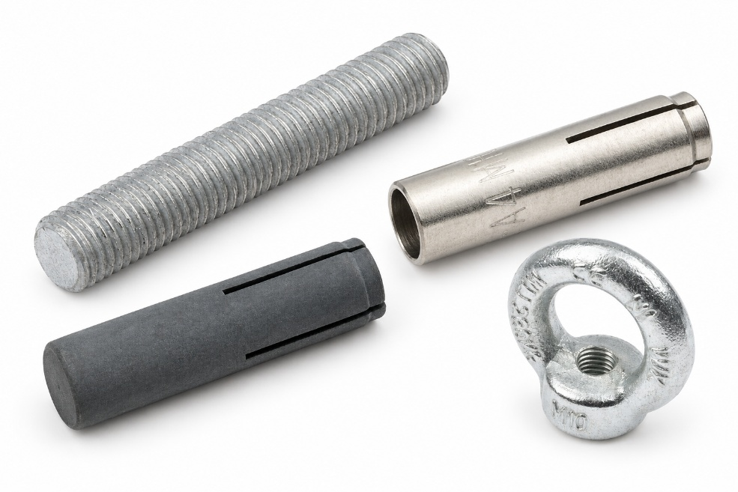
Product components shown for illustration. NFG LH marking and final packaging specifications to be confirmed.

